# Rescue README

## About the Project/Project Title

We are creating a database and interface that will connect local animal shelters’ info about dogs with our client for potential rescue training.

## Motivation

Grazioso Salvare is a company that trains rescue dogs. They are on the lookout for more dogs of certain breeds and ages to train them to be used in emergency and disaster situations. The client also wants the app to be open source so that other companies may use it to identify training candidates in their local areas as well.

## Getting Started

To get started, you will need to have any program that can run Python as well as MongoDB installed. After that, you need to import your local shelters database using mongo import tool [linked here](https://www.mongodb.com/docs/database-tools/mongoimport/).

To import the database we used the following command inside the linux shell.

mongoimport --username="${MONGO_USER}" --password="${MONGO_PASS}" --port="${MONGO_PORT}" --host="${MONGO_HOST}" --db AAC --collection animals --authenticationDatabase admin –type csv –headerline –file /usr/local/datasets/aac_shelter_outcomes.csv

Here is a screenshot of successful import as well as switching to and using the database.

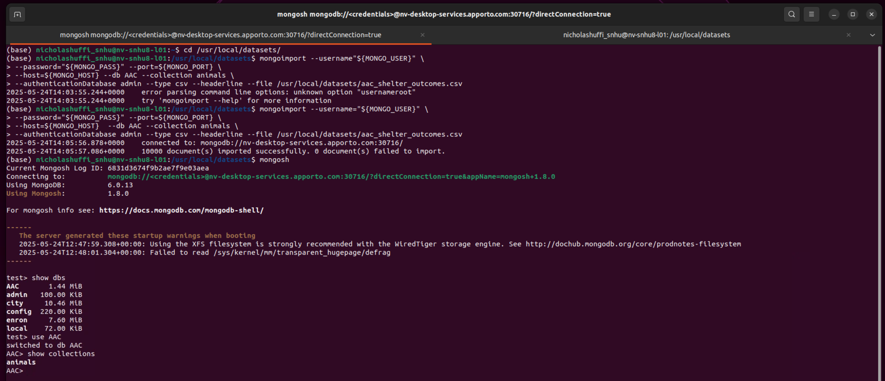

You will need to swap out usernames and passwords as necessary for your own system.

Next we created a user for the AAC database on the admin account using the following shell commands.

Db.createUser({user:’aacuser’, pwd: ‘password’, roles: [{role:’readWrite’, db:’AAC’},

{role:’read’, db:’admin’}, {role:’read’, db:’test’}]})

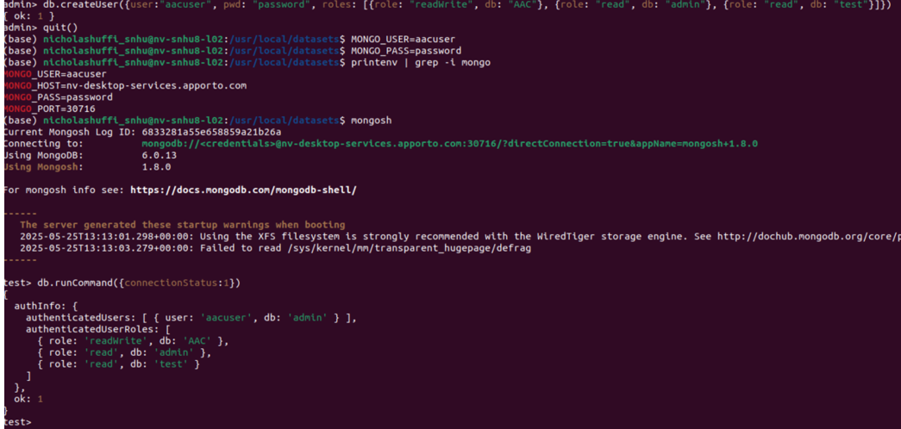

The screenshot above shows successful creation of the account as well as the connection status showing the account details after connecting.

## Installation

You will need MongoDB and something to run Python and PyMongo.

Here is a link to installing [MongoDB](https://www.mongodb.com/docs/manual/installation/) and [PyMongo](https://pymongo.readthedocs.io/en/stable/installation.html).

Here is a link to [Jupyter Notebook](https://jupyter.org/install).

You can also use an IDE of your choice such as PyCharm or Visual Studios

We created a CRUD class for use as middleware between the dashboard and the database. We used PyMongo as it is the officially supported driver for Python and MongoDB.

## Usage

### Code Example

# Create method to implement the R in CRUD.  
 def read(self, data):  
 if data is not None:  
 results_list = list(self.database.animals.find(data))  
 if results_list:  
 return results_list  
 else:  
 return list()  
   
 else:  
 # Made the exception because I can't fathom a reason as to why we  
 # would just want to return the entire collection  
 raise Exception("Nothing to find, because data parameter is empty")

### Tests

Here we used Jupyter Notebook to import our Python module and create an instance of the class. Then we used our read function to find all documents that met the criteria of our search.

### Screenshots

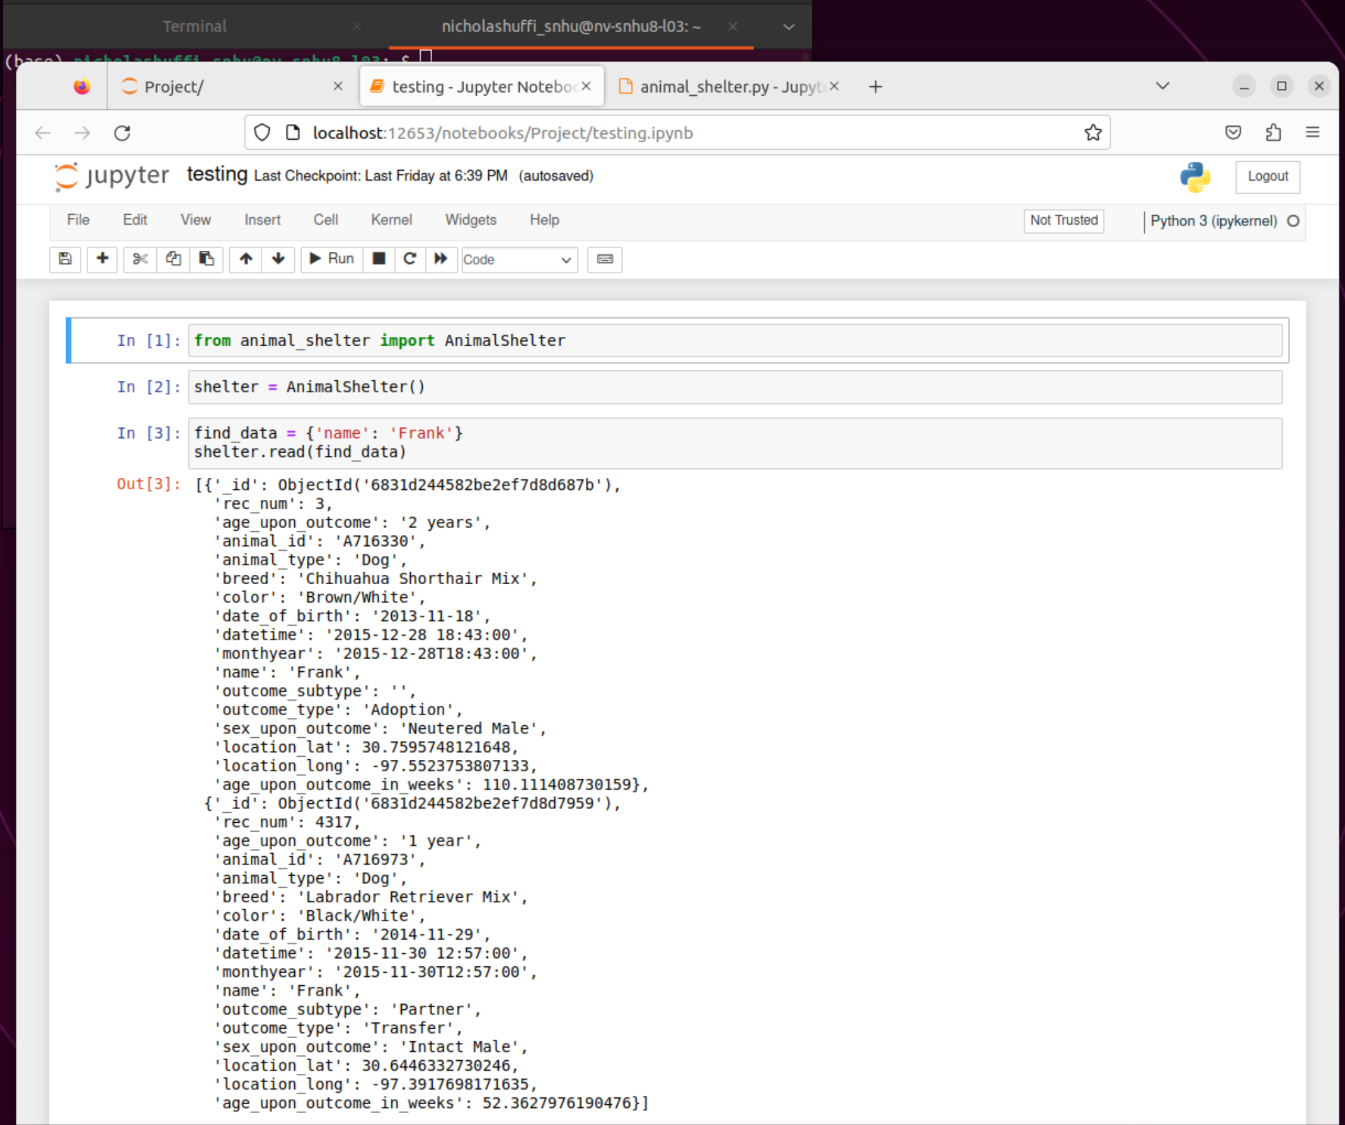

### Code Example

# Complete this create method to implement the C in CRUD.

def create(self, data):

if data is not None:

# data should be a dictionary

insert_result = self.database.animals.insert_one(data)

if insert_result.inserted_id:

return True

else:

return False

else:

raise Exception("Nothing to save, because data parameter is empty")

### Tests

Here we used Jupyter Notebook to import our Python module and create an instance of the class. Then we used our create function to create a test document, followed by our read method to ensure that it was created.

### Screenshots

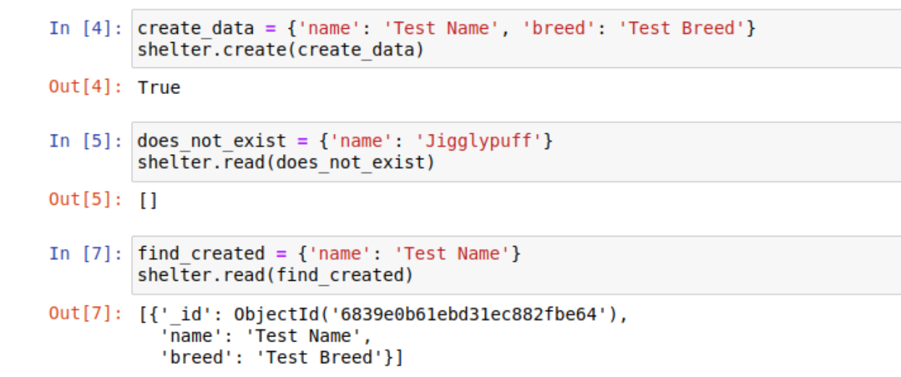

### Code Example

# Create method to implement the U in CRUD

def update(self, findData, updateData):

if findData is not None and updateData is not None:

results = self.database.animals.find(findData)

updatedDocs = 0

for doc in results:

self.database.animals.update_one(doc, updateData)

updatedDocs+=1

return updatedDocs

else:

raise Exception("Nothing to find, or nothing to change")

### Tests

Here we used Jupyter Notebook to import our Python module and create an instance of the class. Then we used our update function to change the name of several documents, followed by a read to show the changes. Notice we changed the two documents from the earlier test of the read function.

### Screenshots

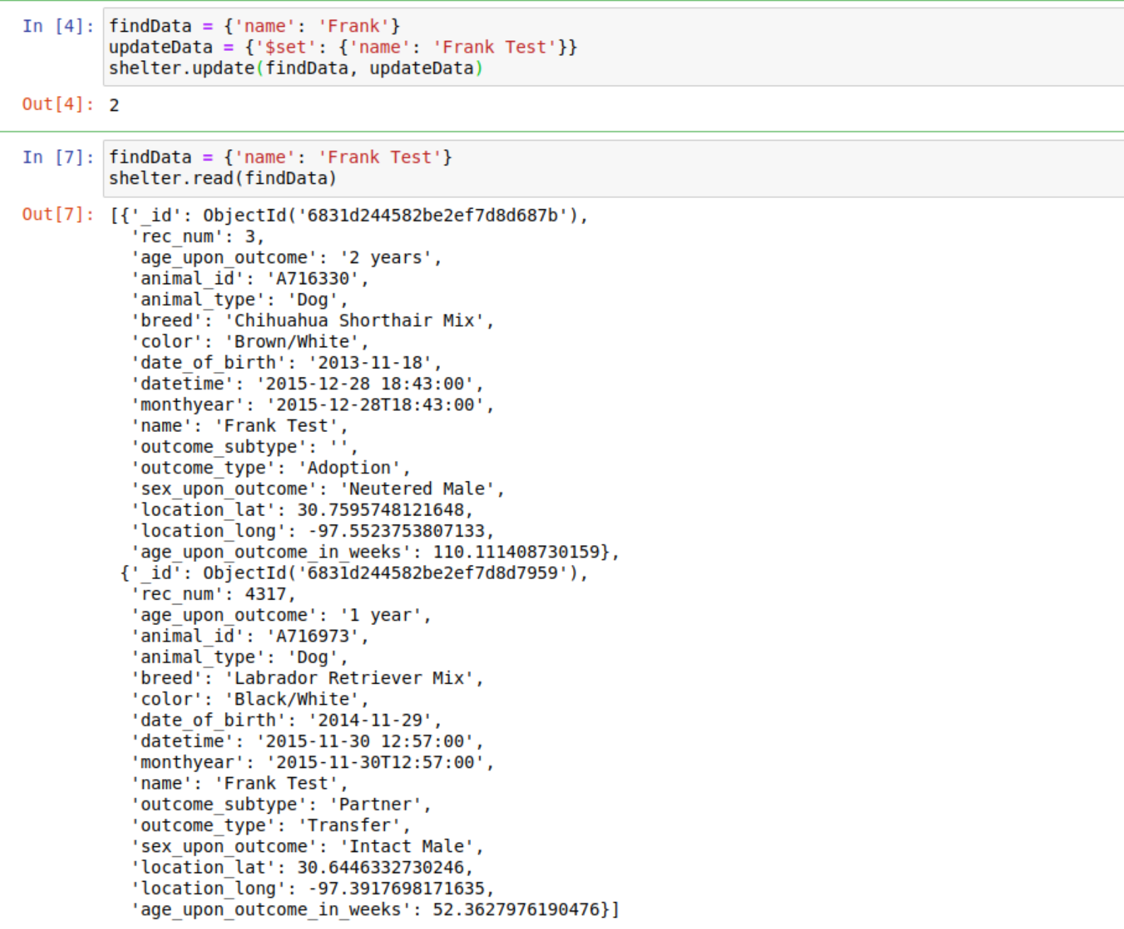

### Code Example

# Create method to implement the D in CRUD

def delete(self, data):

if data is not None:

results = self.database.animals.find(data)

deletedDocs = 0

for doc in results:

self.database.animals.delete_one(doc)

deletedDocs+=1

return deletedDocs

else:

raise Exception("Nothing to delete, because data parameter is empty")

### Tests

Here we used Jupyter Notebook to import our Python module and create an instance of the class. Then we used our delete function to delete the test document we created earlier followed by a read to show the deletion took effect.

### Screenshots

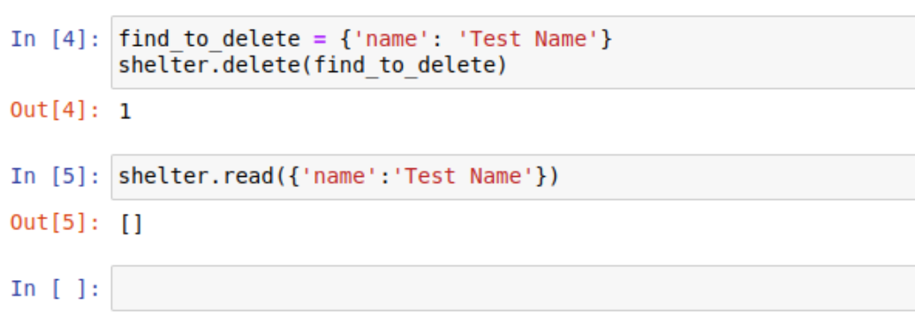

**Dashboard Usage**

Here is the dashboard in its base state upon being accessed.

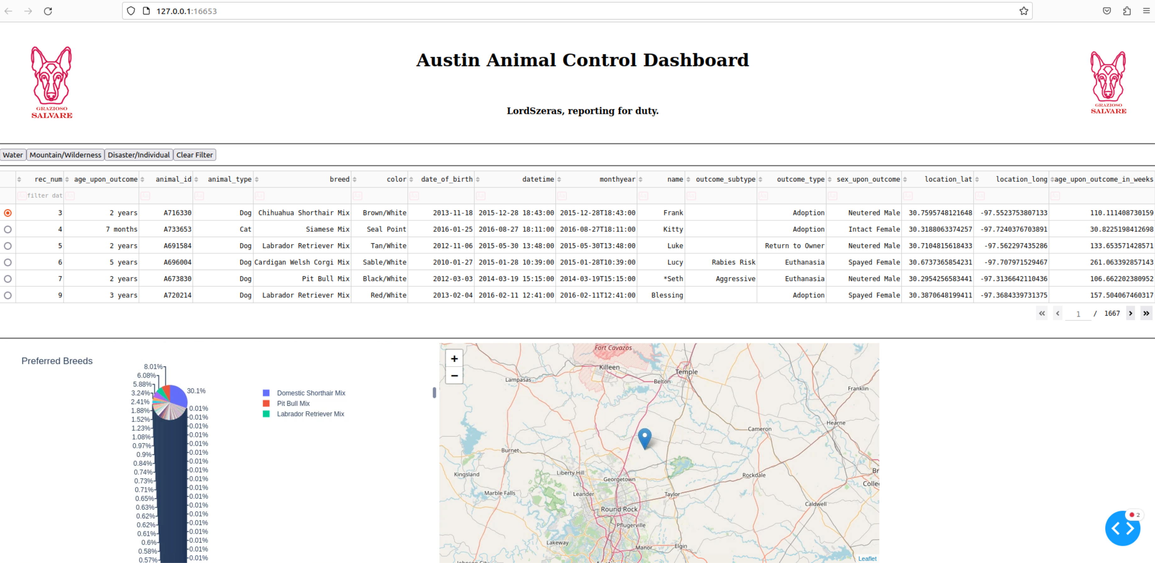

There are buttons at the top left to execute queries based upon the client’s needs for certain breeds and age ranges in the dogs they look for as well as a table to show each dog and a graph and map to visualize the data and show the selected dog’s location.

The following show the changes to the dashboard after executing the query buttons to narrow down the different dogs shown on the table.

Water Rescue

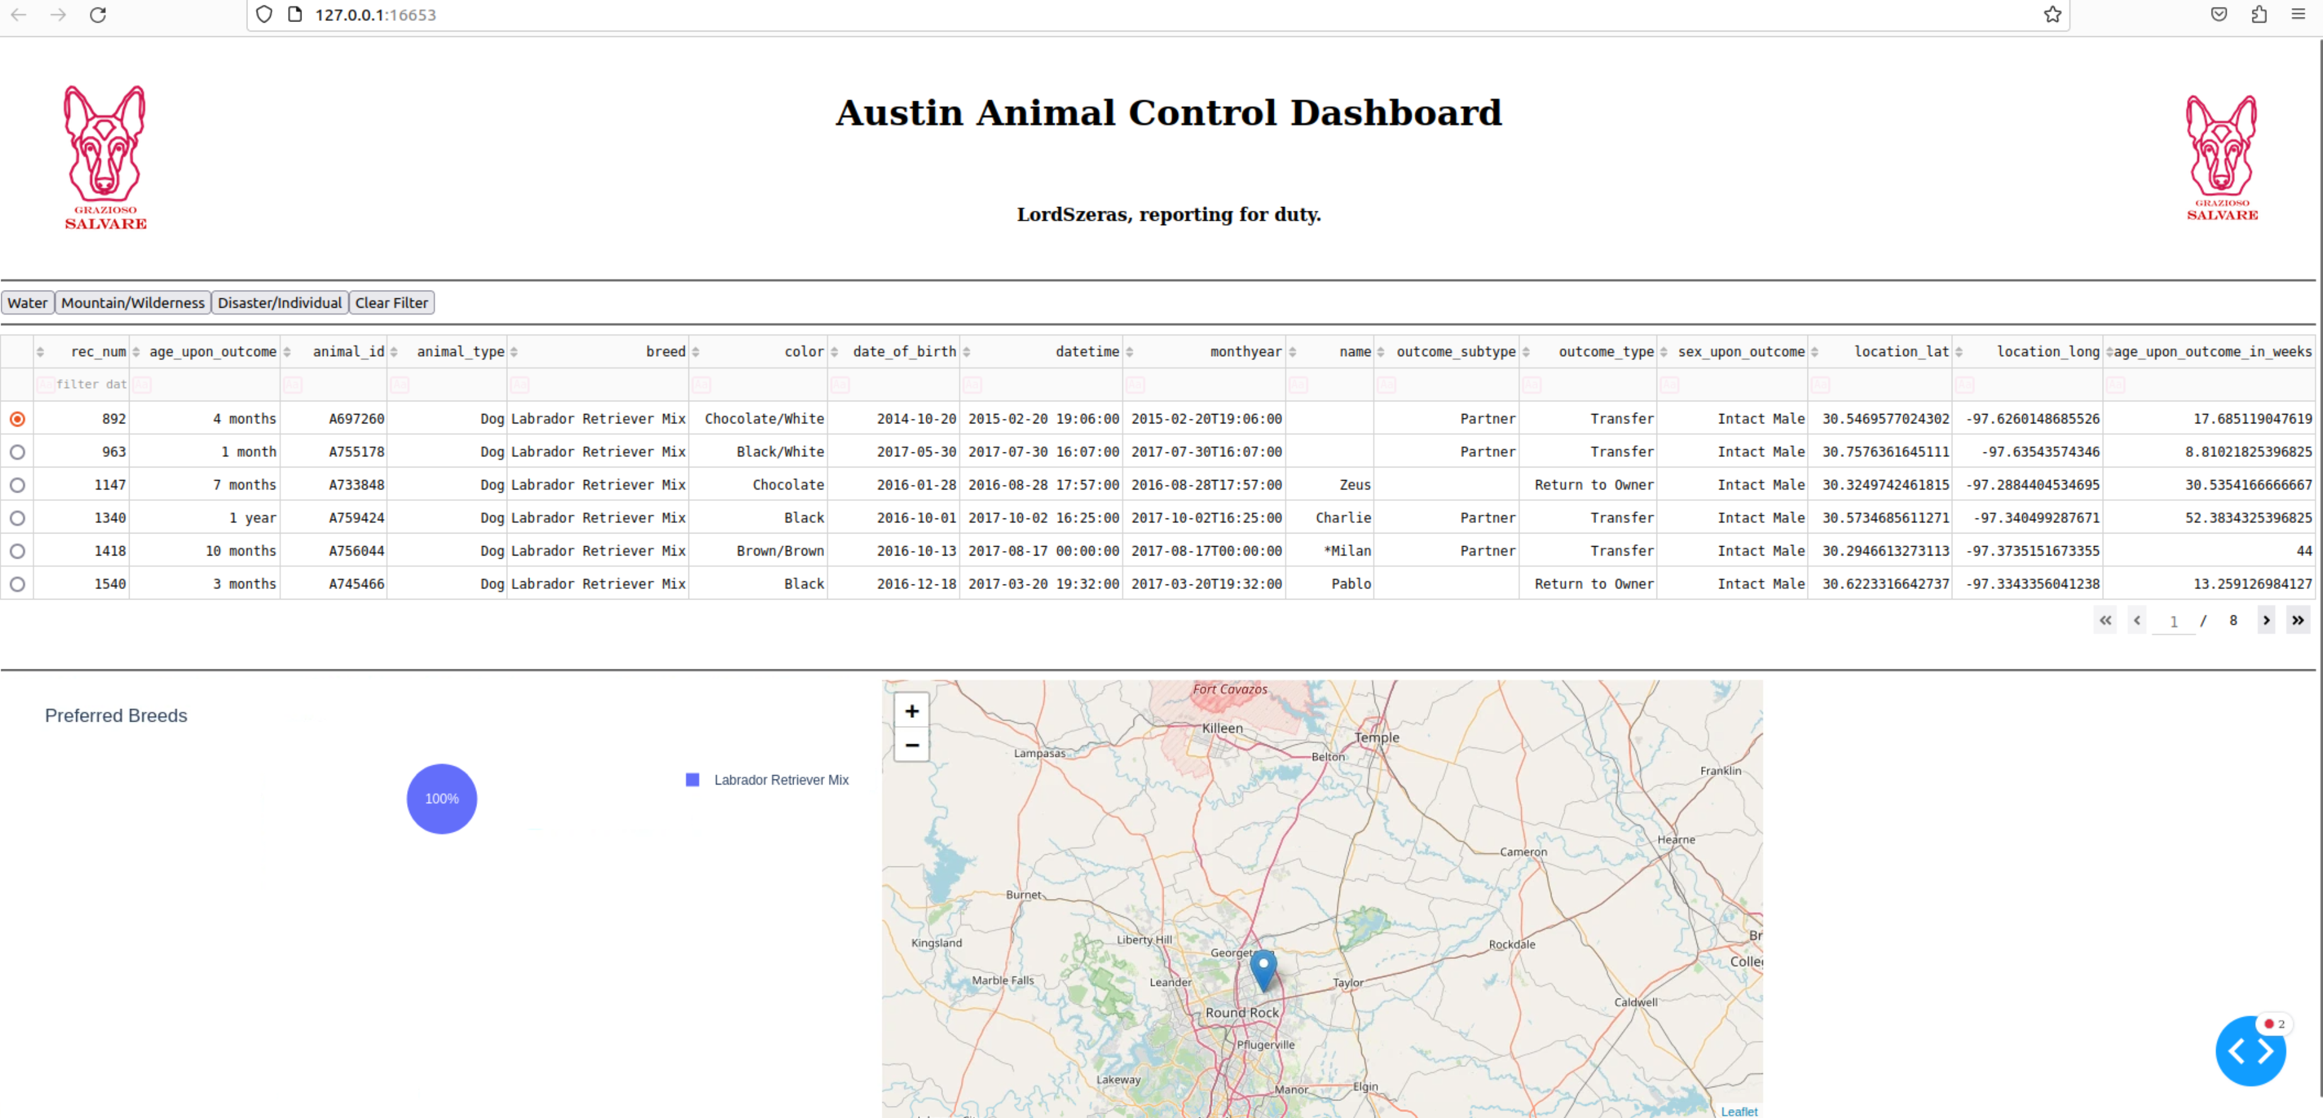

Mountain and Wilderness

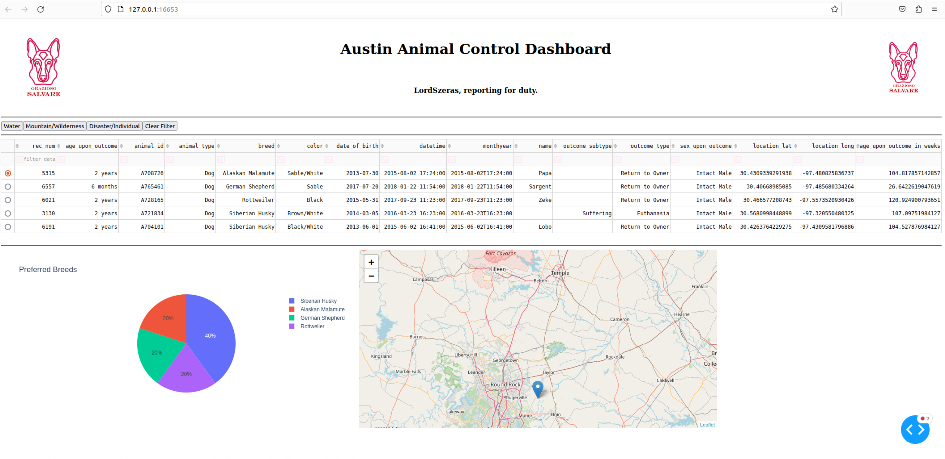

Disaster and Individual

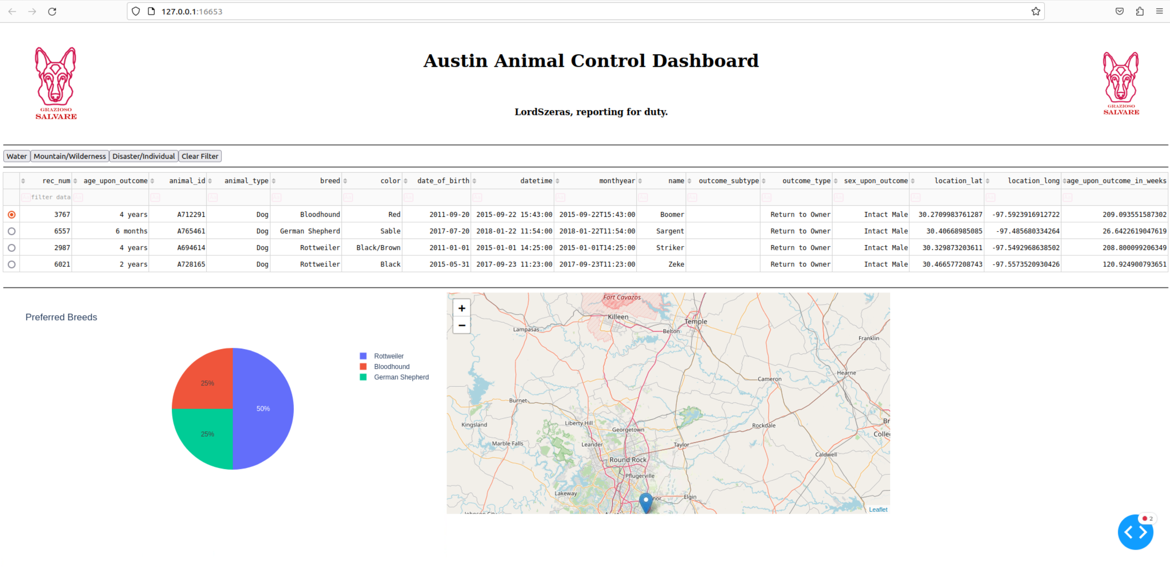

Finally, a return to the full result table using the clear filter option.

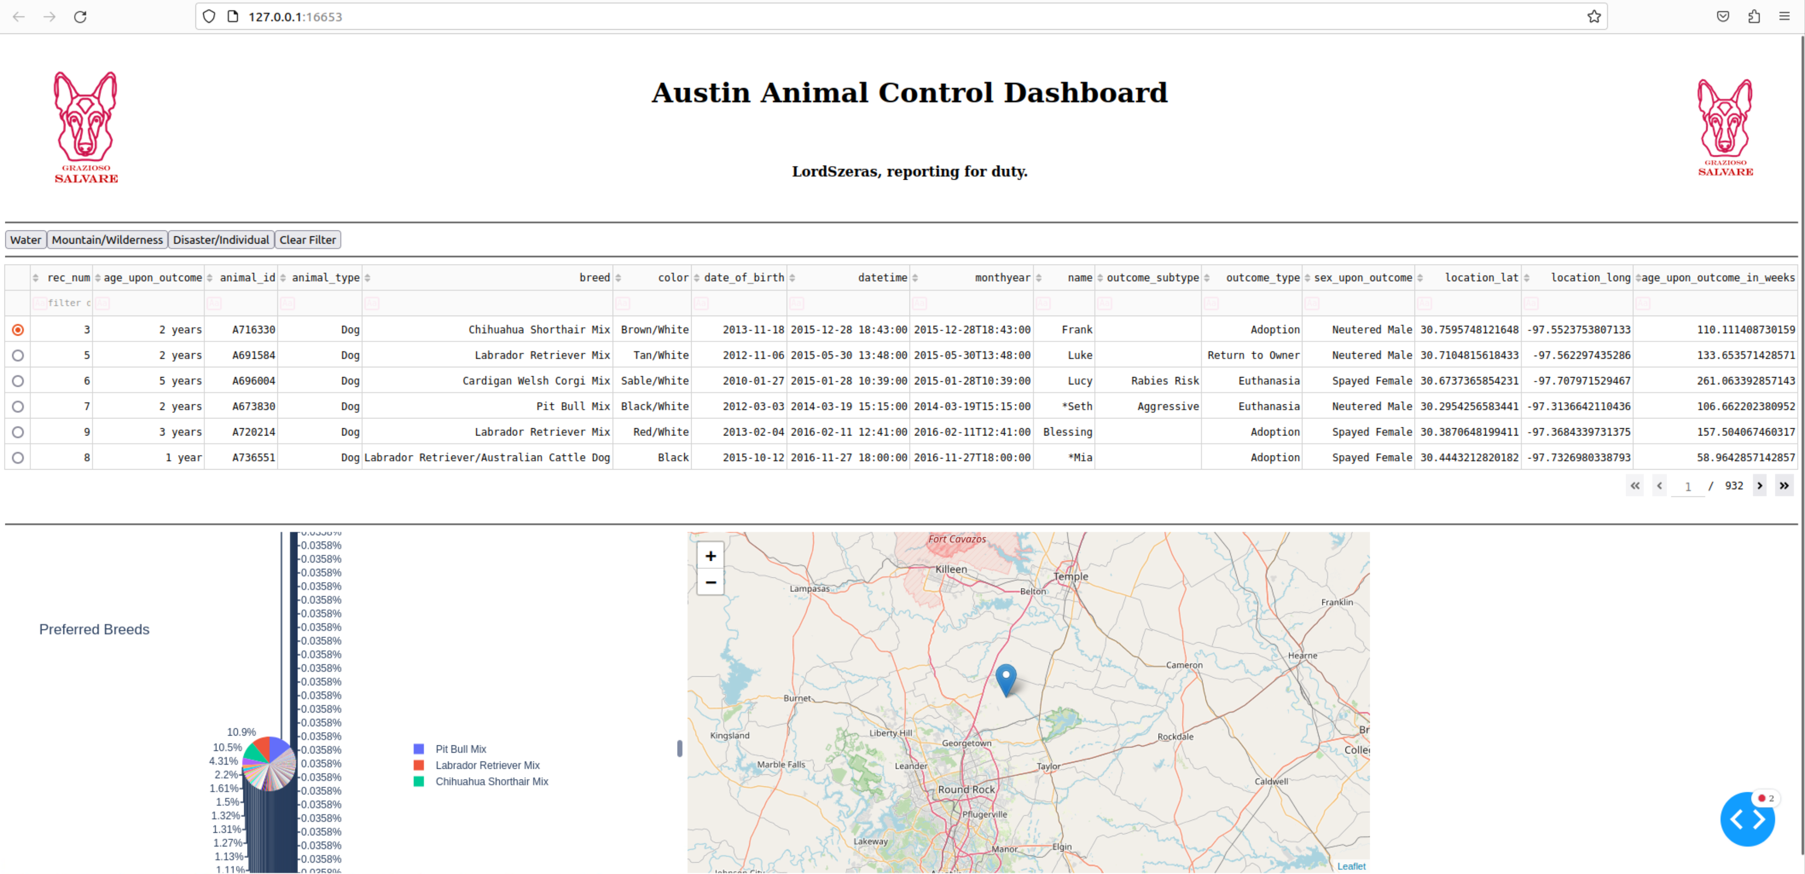

**Challenges**

There were several challenges involved in this project. First, I had an unfamiliarity with HTML, so even using the simplified functions in Dash proved difficult at first as I had to constantly reference what the HTML equivalent was and how I needed to apply it. The second challenge was learning MongoDB. While I have worked with SQL, it was a bit of a challenge learning the query structure of Mongo at first. The third challenge was with Dahs and Plotly. A lot of the documentation explaining the capabilities of the libraries are great, but there are places where improvements could be made. Luckily, the structure of each dash component and it connection to Plotly follows a scheme and is therefor capable of being deciphered in cases where things aren’t spelled out.

## Contact

Your name: Nicholas Huffines